**Model**

Sketch was made then it was revolved in around x-axis to get American football. Domain was modelled with 10c ahead of ball and 10c from top and bottom wall so domains walls don’t have any effect of body under consideration. To capture true wake characteristics, 20c dimension was given at back.

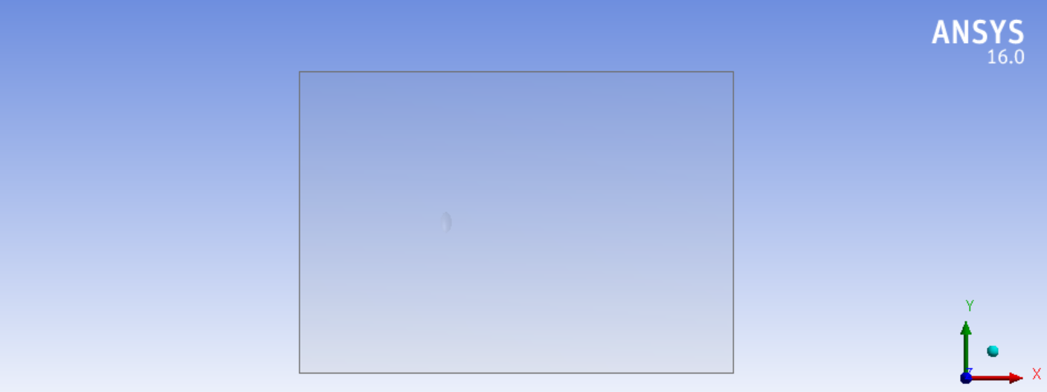

**Mesh**

Unstructured mesh constituting of tetrahedral elements was made. As it was curved surface curvature-based refinement was used. Curvature angle used was 8 degree to capture the curve of football. Finally, the domain having tetrahedrons with minimum orthogonal quality of 0.1 and skewness of 0.738.

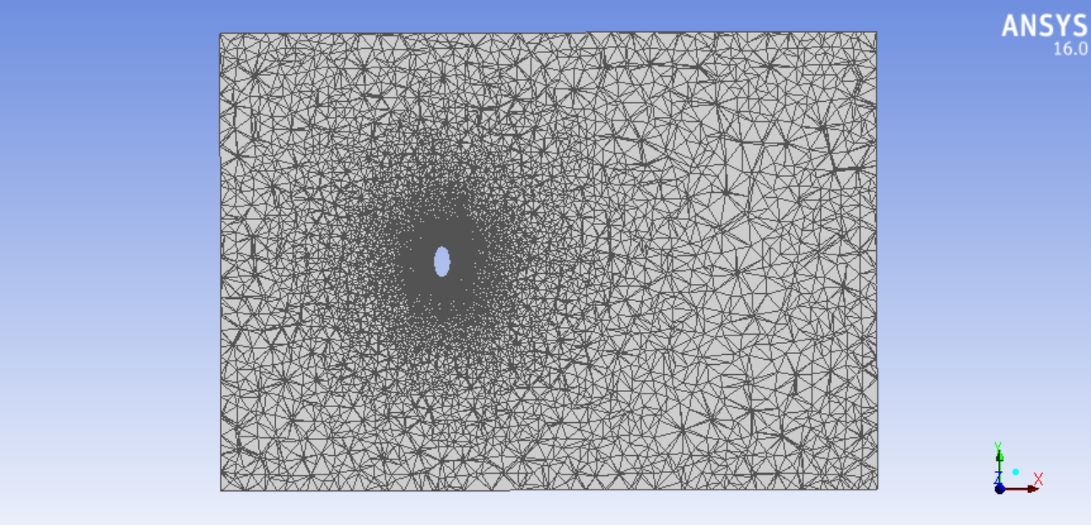

**Analysis**

Atmospheric conditions mentioned below

pressure = 101325 Pa

density = 1.22 kg/m3

viscosity = 1.65e-5

boundary conditions

Velocity inlet with velocity of 16.67m/s was given. Domain walls was also given velocity inlet so domain walls have no effect on football. Football was given wall with no slip and pressure outlet was given.

Turbulence model

Spalart- Allmaras (S-A) model was used as its best suited for adverse pressure gradient. Flow when moves over blunt body it would separates away with formation of wake. To capture the effects of wake SA model was good approach. Moreover, its good for use for both structured and unstructured mesh.

standard initialization from inlet using SIMPLE scheme of pressure-velocity coupling. Convergence criteria of 1e-6 was used. Residuals converged giving CD value of 0.1885 and CL value

of 0.0034. High value of CD is due to blunt shape of football there by low value of CL.

**Contours**

Velocity contour

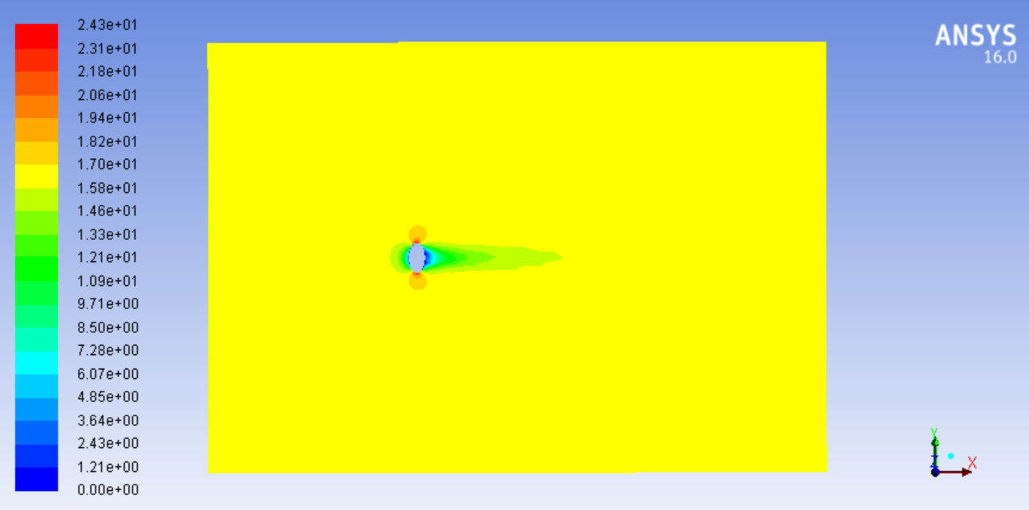

As it can be seen except the vicinity of football the velocity is 16.67 m/s. but when flow approaches the football it stagnates at the point making velocity zero. At the edges velocity trails down spo at that point red area is indicated by contour. Wake can clearly be observed due to shape of body which indicate more streamline the body less wake.

Static pressure

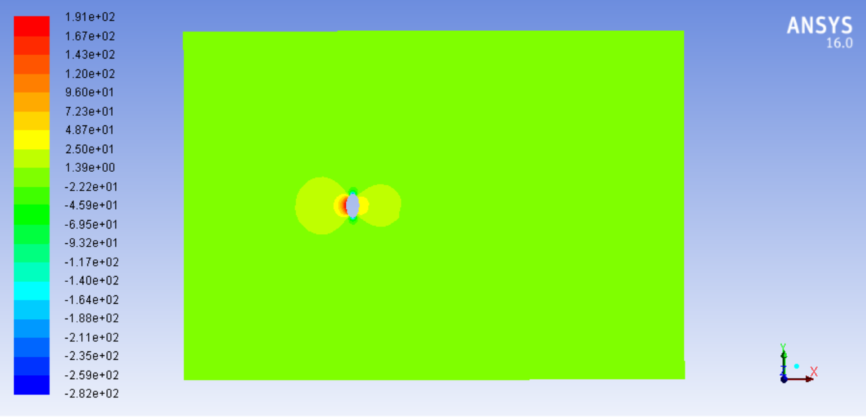

This pressure contour indicated the stagnation of flow as the flow strikes with football thus making maximum pressure at front face of football.